So you are fond of pizzas and looking to order this yummiest cheesy delicacy which is mouth-watering and all-time favourite food. We are glad that you have landed on the right page as we have curated exclusive and most relevant information, including history, timeline, best deals, offers, and much more, for one of your favourite pizza stores-PizzaHut.

The page is aimed to make your pizza buying experience easier, answer frequently asked questions, and will also guide you on how to save those extra bucks on your order.

You can read and find the following details related to PizzaHut here.

**Table of Contents**

|  |  |
| --- | --- |
| 1. Understanding the online food industry in India | a. Why and how is the online food industry growth in India?  b. How has covid impacted the growth of the industry?  c. How is Pizza Hut performing in the online ordering space? |
| 2. Analysing the digital footprints of Pizza Hut | a. Understanding what Google says  b. Pizza Hut's timeline  c. A keynote from PizzaHut leadership |
| 3. How to make your pizza purchase decision easier | a. 5 reasons why you should buy from Pizza hut’s online platform  b. Top deals on Pizza hut website (4 lines to be written about each deal)  c. Pizza hut App – Benefits of installing |
| 4. Ways to save extra bucks while placing your order on Pizza hut online | a. Which are the most commonly used Pizza hut offers?  b. Why choose Rezgari for Pizza hut coupons and offers?  c. What are the different bank and wallet offers one can apply for Pizza hut online ordering?  d. Does Pizza hut offer Free Delivery on online ordering?  e. Does Pizza hut offer additional discounts for ordering on the APP?  f. What is Pizza hut’s Wednesday offer?  g. How can I save more through Pizza hut’s Friday offer? |
| 5. FAQs | a. FAQs related to placing your order online on Pizza but  b. FAQs related to Pizza hut online ordering |

**Understanding the Online Food Industry in India**

**a. Why and how is the online food Industry growth in India?**

The online food industry in India is growing in tandem with the rapidly evolving lifestyle patterns and changing eating habits of today's generation. An increase in disposable incomes and hectic work schedules have further popularized online food delivery, especially in urban locations. Expected to become an $8 billion market by 2022 and steadily growing at a CAGR of 25-30 percent, India's online food industry is massive in size. ([Source](https://www.freepressjournal.in/business/indias-online-food-market-to-grow-at-8-billion-by-2022-report))

**b. How has covid impacted the growth of the industry?**

COVID-19 has impacted the growth of the online food industry in two major ways-order volume, which significantly went down and up, and profitability, which saw a rapid upswing.

Furthermore, pandemic-induced lockdowns have also positively impacted the online food delivery industry in India by fulfilling the urge to eat outside for an increasing number of customers. To leverage this opportunity,  many online leading players, including Pizza Hut, have introduced contactless delivery services.

**c. How Is Pizza Hut Performing In The Online Ordering Space?**

Since its inception in 1958, PizzaHut has grown remarkably to over 18000 quick-serve pizza outlets around the world. However, much has changed since then as an increasing number of customers want their pizzas delivered or ready for takeout. And to navigate customer expectations and stay competitive, PizzaHut is focused on serving their patrons where and when they want to eat, using a robust online ordering system.

Online or digital orders are now a significant chunk of all Pizzahut's delivery orders, where the company is enabling its customers to order its favourite menu items via the website or Pizza Hut mobile app.

**Analysing the Digital Footprints of Pizza Hut India**

a. **What google says?**

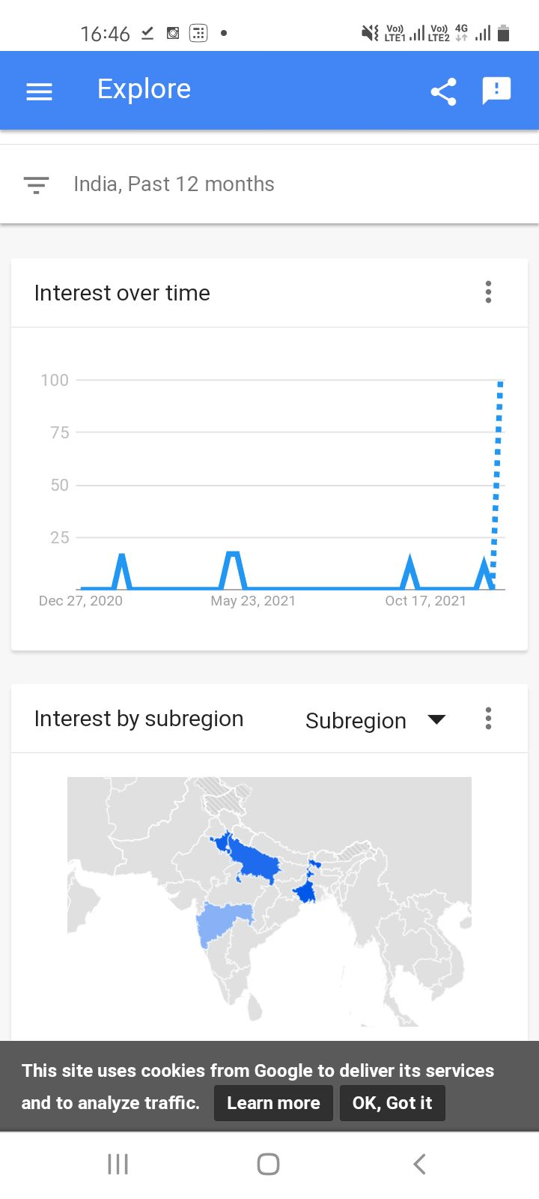Here is the Google Trend graph showing the growing interest and demand around online delivery for Pizza Hut.

b. **Pizza Hut's timeline**

Learn more about the history and growth of Pizza Hut below-

Pizza Hut, a subsidiary of Yum! Brands, Inc. is a renowned name for serving and delivering more pizzas than any other company in the world. Founded in 1958, Pizza Hut has grown steadily and soon become the most-recognized pizza brand in the world, operating more than 18000 restaurants in over 100 countries.

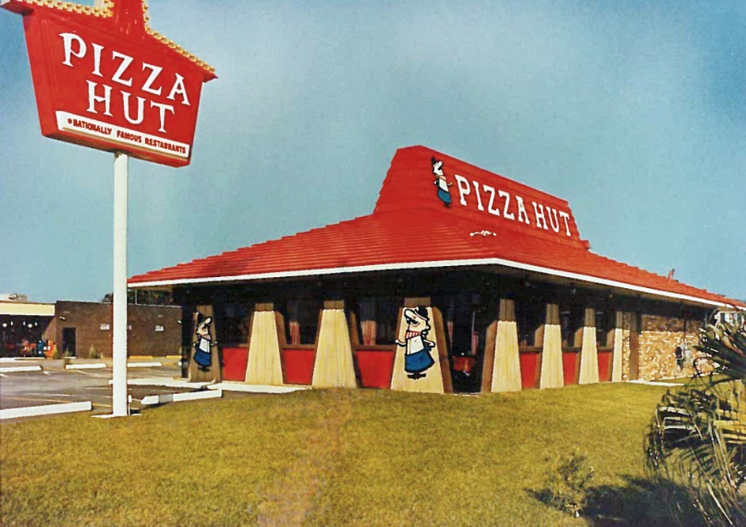[Source](https://blog.pizzahut.com/wp-content/uploads/2015/07/Red-Roof-1080x761.jpg)

Having been entered the Indian market first time in 1996 and opened its very first restaurant in Bangalore, PizzaHut has since then successfully captured a noteworthy and significant share of the overall pizza market in India and has consistently maintained impressive growth rate of over 40 percent per annum.

The brand offers an exciting menu consisting of its signature yummy pizzas, pasta, sides, appetizers, desserts, and beverages. The robust dining experience of Pizza Hut has been recognized by *Brand Equity* to make it the '*Most Trusted Food Service Brand*' for continuous 13 years.

Pizza Hut India was recently (in 2020) recognised as the 18th best and most trusted brand in the country by Campaign Asia and also felicitated with the title of India's 70 Most Trusted Power Brands.

Other noteworthy awards and accolades in the name of Pizza Hut include the award for *Most Admired Retailer of the year for Digital Marketing Campaign,* *Innovative Use of Technology award by exchange4media Indian Marketing Awards 2017*,  and *Best Omni-channel campaign management and marketing automation at the IAMAI 2018 Awards*. It is considered the most preferred pizza brand in India because of its freshest, tastiest & affordable range of Pizzas.

**c. A keynote from the leadership of Pizza hut in India and globally about expansion in the Indian market**

"*Pizza Hut has been on a steady growth trajectory and plans to enter several new cities by the end of 2021 to expand its presence in tier-2 and tier-3 cities alongside metros,” the pizza QSR chain said.*

*Merrill Pereyra, Managing Director, Pizza Hut Indian Subcontinent, also said, “We are truly humbled and grateful for the unwavering love and trust of our customers and thank them for this momentous achievement. We also owe this success to our franchisee partners and the entire extended Pizza Hut family, who work passionately and relentlessly every single day for the love of Pizza. We are deeply invested in India and look forward to growing the brand aggressively in the next few years.*”

**Making Your Pizza Purchase Decision  Easier**

**a. 5 reasons why you should buy from Pizza hut’s online platform**

Here are key benefits of online ordering from pizza hut-

1. Allows you to easily personalize your orders as you can choose your add-ons in a matter of clicks.
2. Ease of receiving the order confirmation along with the delivery time on your tablet or smartphone.
3. Opportunity to scan and view the entire menu on either pizza hut website or app.
4. The benefit of several deals offers and discounts exclusively available for online ordering.
5. The convenience of purchasing favourite pizzas and dishes with mobile devices on the pizza hut app.

**b. Top deals on the Pizza hut website**

Here are some of the top deals you can avail on the pizza hut website-

1. **Super Value Deal**

One of the most preferred deals by customers, the deal gives you 2 medium pizzas starting at Rs 599. Here you are allowed to choose any 2 of your favourite medium pizzas.

2. **Flat Rs. 125 off on all Pizza Hut orders**

With this deal, you can enjoy flat Rs. 125 discount on ordering Pizza online. The purchase value here should be Rs. 500 or more. Also, the offer is not valid on deals, and the user must apply the given Promo code at the time of checkout.

3. **Momo Mia Choco Sundae Meal for 1**

With this deal, you can enjoy "Meal for 1" with 1 Personal Momo Mia pizza + 1 Choco Sundae

4. **Buy One Pizza & Get One Free**

This one is a super value deal where you can buy 1 medium pizza from a select range & get another pizza of the same or lesser value for free

**c. Pizza hut App – Benefits of installing**

Installing the official Pizza Hut app can give you a range of benefits to make your online ordering experience smooth and hassle-free. It is the easiest way to order your favourite Pizza, sides, and desserts.

The highlight of the app is that it comes with added contactless ordering features to make it easier for you and your family to get the Pizza you love without any worry.

The app is thoughtfully designed for pizza lovers, making online food delivery and takeout a lot simpler and easier. The app allows you to check out the complete menu, find the best available deals, save orders and even earn free Pizza with Hut Rewards.

Among other benefits of installing the pizza hut app include-

* Allows you to reorder in three easy taps
* Helps you track your order with the Pizza Hut Delivery Tracker
* You can use guest checkout to easily order without an account
* Allows you to place future orders up to 7 days in advance and find Pizza Hut locations near you
* You can order contactless delivery, takeout, or curbside pick up with this simple app
* Gives an option to pay with cash, card, or Pizza Hut gift card

**Ways in which you can save extra bucks while placing your order on Pizza hut online!**

* **Which are the most commonly used Pizza hut offers?**

Among the most commonly used Pizza hut offers are-

1. Pizza Hut Wednesday offer- Get one medium pan pizza at flat 50% off
2. 1 plus 1: weekend offer-Super value deal- 2 medium pizzas (starting at Rs.599 only) at 43% off
3. Flat Rs. 125 Off on Orders above Rs. 500- not valid on deals
4. Free Garlic Bread Stix on Orders above Rs. 300-Place an order of min Rs. 300 and get free garlic bread six
5. Flat Rs. 125 Off on Orders above Rs. 500- not valid on deals

* **Why choose Rezgari for Pizza hut coupons and offers?**

Choosing Rezgari for Pizza hut coupons and offers to give you-

a. Real-time deals, promo codes, and offer updates from all online pizza hut stores

b. The coupons and offers for Pizza hut are incredibly easy to access and use with Rezgari. All you need to do is click on the site and access a list of offers to choose from.

c. Rezgari offers you the specified discount for a range of pizzas sold on pizza hut online.

* **What are the different bank and wallet offers one can apply for Pizza hut online ordering?**

There is good news for all the bank and wallet users as Pizza hut has come up with exclusive bank and wallet offers. On choosing digital wallets such as FreeCharge, Paytm, Mobikwik, and other e-wallets, you will get significant off while placing an online order for your favourite Pizza.

Also, if you’re an ICICI, HDFC, Citibank user, you can avail of several exclusive Pizza Hut bank offers. These offers are valid in all its online stores. Additionally, you can also use the Pizza Hut promo code to get an extra discount. All the latest Pizza Hut coupon codes are listed here at Rezgari**.**

* **Does Pizza hut offer Free Delivery on online ordering?**

Yes, while ordering your favourite Pizza online, the delivery is free. In addition to this, you can use the various Pizza Hut coupon codes to maximize the discount.

* **Does Pizza hut offer additional discounts for ordering on the APP?**

There are several offers available when you order on the Pizza hut app. For example, Pizza Hut buy one get one free offers are available on both the Pizza Hut website or mobile application based on the availability of the current and existing deals and are subject to change.

* **What is Pizza hut’s Wednesday offer?**

Pizza hut's exciting Wednesday offer gives you a flat 50% OFF on all media pan pizzas. All you need to do is buy pizzas online at Pizza Hut and get the best deals on your orders. Simply apply coupons on your orders to get this deal. Also, take note that this offer is valid only on the purchase of 2 pizzas.

* **How can I save more through Pizza hut’s Friday offer?**

Pizza hut's Friday unlimited combo offer allows you to save more by availing of either veg pizzas and unlimited Pepsi @ 269 or unlimited non -veg pizzas and unlimited Pepsi @ 299. Note that the offer is valid on select medium pizzas (country feast & veggie feast for veg and chicken sausage & spiced chicken meatballs for non-veg). Also, the deal is non-shareable, i.e., one guest can consume only one UPF deal, and the offer is valid for in-store consumption only.

**FAQs while placing your order online on PizzaHut**

Here are some of the FAQs related to placing an order online on PizzaHut

**a. Questions  related to contactless delivery**

* **How do I avail of contactless delivery?**

To avail of contactless delivery, you will have to opt for the ‘contactless delivery’ option while making your order online (web/m-site/app). In some cases, pizza hut's rider may also get in touch with you to understand where you need your Pizza to be placed.

* **Can I do Cash-on-delivery for contactless delivery?**

No, there is no cash-on-delivery option for contactless delivery as the aim is to make the entire process contactless.

* **Do I have to pay extra to avail of the contactless delivery service?**

No, there are no extra charges to avail of the contactless delivery service.

**b. Questions related to PizzaHut online ordering**

* **How will I know the restaurant has received my online order?**

As soon as you submit your order, the Order Confirmation page will reflect the time your order was received along with an estimated time that your order will be ready for either pick-up or delivery. In addition to this, you will also receive a confirmation email at the email address provided by you when placing the order.

* **Can I use my coupon code with any other offer?**

Unfortunately, coupons cannot be clubbed together with any other offer/scheme. You can use one coupon for one transaction only, and the company reserves the right to decline any coupon based on the availability and the offer's terms and conditions.

* **Can I use my coupon after the expiry of the validity period?**

No. The coupons are valid for a specified period only and will not be accepted after the expiry of the validity period.

* **Can I modify/cancel my online order?**

Once you place the online order, it cannot be modified or cancelled either through the website or by calling the restaurant/call centre.

* **Are the 30 Minutes or free offer applicable every day?**

No. 30 minutes or free offer is not applicable every day. The days when the offer is not valid include New Year’s Eve, religious festivals,  public holidays, Wednesdays, and orders for which the 50% OFF offer has already been availed. The service promise may also be withdrawn temporarily in case of difficult operating conditions for delivery, which are generally announced at the time of order taking.